Serving SpecterX from the Customer’s Domain

Introduction
This manual provides step-by-step instructions on how to set up URL redirection from <customer.domain> to <customers_cloudfront_in_specterx> in SpecterX's AWS Cloud environment.

The unique aspect of this redirection is that the URL displayed in users' browsers will remain as <customer.domain>, while the backend is configured to serve content from <customers_cloudfront_in_specterx>.

This redirection should seamlessly forward users from <customer.domain> to <customers_cloudfront_in_specterx> while preserving query parameters and supporting both HTTP and HTTPS protocols for all modern web browsers.

Prerequisites
Before proceeding, make sure you have the following:

For SpecterX engineer
- Access to the AWS Cloud environment where <customers_cloudfront_in_specterx> is hosted.

For customer engineer
- Administrative access to the DNS settings for <customer.domain>.
- Administrative access to the NGINX server.

Configuration Steps

DNS Configuration [Performed by Customer]
  - Log in to your DNS provider's control panel or dashboard where <customer.domain> is registered.
  - Create a DNS record for <customer.domain> with a type of "CNAME" (Canonical Name) and set the value to the NGINX server.
Example: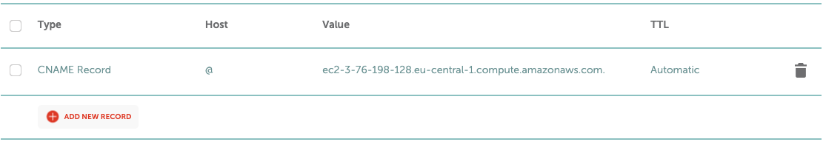

NGINX Configuration [Performed by Customer / Provider]
- SSH into the server where the NGINX server is hosted.
- Edit the NGINX configuration file, typically found at /etc/nginx/nginx.conf or in a site-specific configuration file (e.g., /etc/nginx/sites-available/<customer.domain>).
- Add the following NGINX server block configuration:

server {
listen 80;
listen [::]:80;
server_name <customer.domain>;

location / {
return 301 https://$host$request_uri;
}

location ~ /.well-known/acme-challenge {
allow all;
root /tmp/acme_challenge;
}
}

server {

listen 443 ssl;
listen [::]:443 ssl;

#Set your domain here
server_name <customer.domain>;

#Your SSL certificate and private key
ssl_certificate /etc/letsencrypt/live/<customer.domain>/fullchain.pem;
ssl_certificate_key /etc/letsencrypt/live/<customer.domain>/privkey.pem;

location / {

#Ask SpecterX for your cloudfront domain
proxy_pass https://<customers_cloudfront_in_specterx>;

#Set SpecterX Cloudfront domain here
proxy_set_header Host <customers_cloudfront_in_specterx>;

proxy_set_header X-Real-IP $remote_addr;
proxy_set_header X-Forwarded-For $proxy_add_x_forwarded_for;
proxy_set_header X-Forwarded-Proto $scheme;
proxy_ssl_verify off;

}
}

*** Make sure to replace the SSL certificate and private key paths and proxy_pass URL with your actual values.
Save and exit the configuration file, reload NGINX to apply the changes:

sudo systemctl reload nginx



AWS CloudFront Configuration [Performed by Provider]
- Log in to the AWS Management Console.
- Navigate to the CloudFront service.
- Select the CloudFront distribution associated with <customers_cloudfront_in_specterx>.
- In the "General" tab of the distribution settings, remove any Alternate Domain Names (CNAMEs) and Custom SSL certificates if configured.
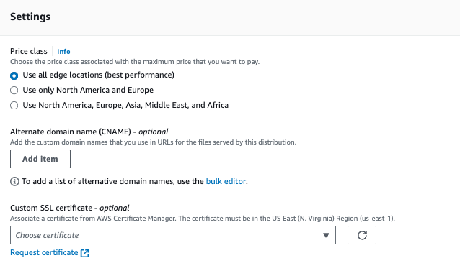

4. Testing and Validation [Performed by Customer and Provided]
- Access <customer.domain> in various web browsers (Chrome, Firefox, Safari, Edge) using both HTTP and HTTPS protocols.
- Ensure that users are seamlessly redirected to <customers_cloudfront_in_specterx>.

Conclusion
You have successfully set up URL redirection from <customer.domain> to <customers_cloudfront_in_specterx> in SpecterX's AWS Cloud environment.
The redirection should work seamlessly for users across different browsers and protocols while preserving the same URL and query parameters.

